1. **Account Management**
   1. **Account Types & Structures**

SalesIQ supports a flexible account type hierarchy, which can be defined and changed within the system. Account Types can be created/edited/removed from the system. The account hierarchy must support at least three different levels.

* + 1. **Corporate HQ -** The highest level of account type. Requires its own account plan as well as the ability to see the plans associated with any other account types related to it.
    2. **Regional Hub -** The second level of account type that will sit under the corporate account type. Requires its own account plan as well as the ability to see the plans associated with any other account types related to it.
    3. **Local Clinic -** The final level of account type. Requires its own account plan as well as the ability to see the plans associated with any other account types related to it.

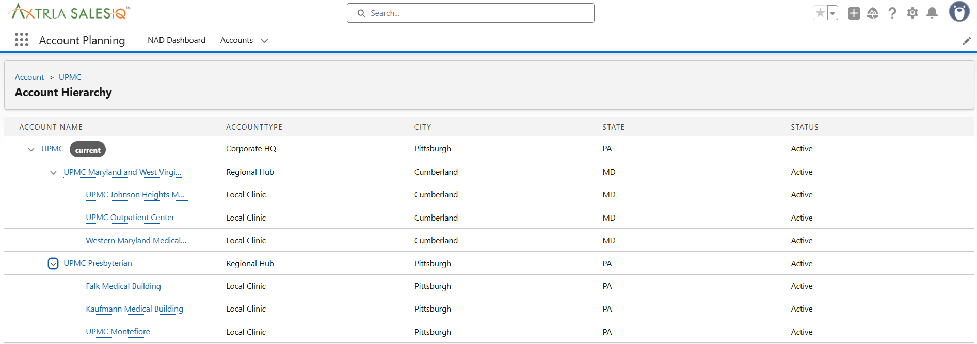

* 1. **Account Profile**
     1. **Collaboration on Patient Engagement**

This component tracks and displays the level of collaboration between teams or stakeholders in driving patient engagement initiatives. It may include data on outreach efforts, programs implemented, and collaboration with healthcare providers or patients. The target value defines a specific goal for collaboration, the number of outreach programs completed within a given timeframe.

* + 1. **Sales YTD**

This shows the year-to-date (YTD) sales performance, including actual sales figures versus target values. It provides real-time insight into the product's market performance.

* + 1. **Product Rank in Preferred Prescribing**

This metric ranks the product in terms of its preference by healthcare providers or key stakeholders for prescribing. It reflects the product's standing within the market.

* + 1. **Customer Satisfaction Score**

This component displays the average customer satisfaction score, reflecting how satisfied customers are with the product or service. It's often based on surveys or feedback tools. It’s calculated on a 5-point scale.

* + 1. **Insights**

The three boxes contain predefined insights that are critical to understanding account performance. These insights could include key metrics, trends, or alerts related to product usage, customer feedback, or sales performance.



* + 1. **Account Management**

Accounts can be created via interface or can be imported through API as per the configurable frequency.

|  |  |
| --- | --- |
| **Field/Feature Name** | **Description** |
| MDM ID | Unique identifier assigned to the account in the Master Data Management system |
| Account Name | The official name of the healthcare organization |
| Parent Account | Indicates the overarching corporate entity or group that owns or manages this account |
| Account Type | Categorizes the nature of the account, such as Corporate HQ, Regional Hub, or Local Clinic |
| Status | Current operational status of the account (e.g., Active, Inactive) |
| Territory | Geographical sales or service region assigned to the account |
| Address | Physical location or mailing address of the account |
| Billing State | U.S. state used for billing and financial records |
| Sales | Total sales value generated from this account |
| No. of Beds | Total number of patient beds available at the facility |
| No. of Patients | Total number of patients served by the account annually |

User with Administrator role can have full access to the accounts view where other user can access the account details as per their assignments.

* + 1. **Account Plan**

Account Plan can be created for each account. Each account is associated to a single plan. Account Plan can be created from the account record, by clicking the “New” in the Account Plan section below.

* 1. **Stakeholders**

Stakeholders can be created/managed at the account level. Each user can have a target list of Stakeholders and is a subset of Stakeholders list. User can mark as a key stakeholder; one can have multiple key stakeholders at User level. User can create/ view stakeholders list at account level.

Stakeholders can be imported from other systems into SalesIQ. The visibility of each stakeholder can be controlled based on users field function. This visibility by field function is included as a part of data import of Stakeholders and Target list.

Each stakeholder profile includes personal and professional details, communication preferences, and their key priorities (“careabouts”).

* + 1. **Stakeholder’s Details**

|  |  |
| --- | --- |
| **Field/Feature Name** | **Description** |
| Stakeholders Name | Full name of the individual stakeholder involved |
| Account | The healthcare organization or facility to which the stakeholder is associated. |
| MDM ID | Unique identifier for the stakeholder in the Master Data Management system. |
| Email | Stakeholder’s email address for communication |
| Phone | Stakeholder’s phone number for direct contact |
| Title | The stakeholder’s official role within the organization |
| Stance | The stakeholder’s attitude or position toward the project (e.g., supportive, neutral, skeptic) |
| Decision Power | Level of authority the stakeholder has in making project-related decisions |
| Reports to | Name of the person to whom this stakeholder directly reports |
| Is Key Stakeholder | Indicates whether the stakeholder plays a critical role |
| Action | Required engagement activities |

* + 1. **Communications**

|  |  |
| --- | --- |
| **Field/Feature Name** | **Description** |
| Check-in Notifications | Flag to show whether proactive check-ins are scheduled |
| Contact Method | Preferred communication channel |
| Frequency | Frequency of communication |
| Start Date | The date the stakeholder engagement began |

* + 1. **Careabouts**

|  |  |
| --- | --- |
| **Field/Feature Name** | **Description** |
| Initiative Name | Key initiatives or priorities that matter to the stakeholder (e.g., clinical pathways, patient education) |

* 1. **Interactions**

The **Interactions Tab** records every communication or engagement with stakeholders, capturing essential details such as the interaction title, description, type, and involved parties.

|  |  |
| --- | --- |
| **Field/Feature Name** | **Description** |
| Interaction Title | A brief, clear title that summarizes the nature of the interaction |
| Description | A short description of the interaction |
| Type | Specifies the interaction format or communication channel |
| Stakeholders Name | Name of the stakeholder involved in the interaction |
| Interaction Date | The date when the interaction occurred or is scheduled to occur |

* 1. **Team**

Organizes and tracks the different teams involved, providing clear identification and departmental associations.

|  |  |
| --- | --- |
| **Field/Feature Name** | **Description** |
| Team Name | The name of the team |
| Team ID | A unique identifier for each team within the system |
| Department | The department to which the team belongs |

* 1. **Members**

Members can be aligned to each account. User can view a list of "Team Members" for the account based upon the role assignments. The **Members Tab** captures key details about each project team member, including their name, role, team, start and end dates, and status.

|  |  |
| --- | --- |
| **Field/Feature Name** | **Description** |
| User | The name of the individual team member |
| Role | The title of the team member |
| Team | The team to which the user belongs |
| Start Date | The date when the team member began working on |
| End Date | The date when the team member is scheduled to leave or complete their role |
| Status | Current status of the team member (e.g., Active, Inactive, On Leave) |

* 1. **Alerts**

Market Events, Alerts and NBAs can be imported from different system based on the configurable frequency. The visibility/access of data can be controlled on the based-on user’s field function. A list of Market events, Alerts and NBAs is displayed for associated accounts and accounts below it. Any Market Events, Alerts and NBAs must be visible to other accounts related to it in account hierarchy.

* + 1. **Market Alerts**

The Market Alerts Tab provides a structured view of critical market developments, including alert name, type, and detailed description.

|  |  |
| --- | --- |
| **Field/Feature Name** | **Description** |
| Alert Name | A brief title summarizing the nature of the market alert |
| Type | Categorizes the alert |
| Description | Provides detailed information about the alert, including context, potential impact, and any recommended next steps |

* + 1. **Next Best Actions**

The **Next Best Actions Tab** offers actionable recommendations for stakeholder engagement. Each entry includes a clearly defined topic, action type, and a suggestion phrased as a direct next step.

|  |  |
| --- | --- |
| **Field/Feature Name** | **Description** |
| Topic | The subject or focus area of the action |
| Action Type | The nature of the action to be taken (e.g., Email, Call, Meeting) |
| Accepted | Indicates whether the assigned user has accepted the recommended action (Yes/No) |
| Schedule Date | The date by which the action should be taken |
| Product | The product associated with the action |
| Stakeholder | The stakeholder involved in the action |
| Assigned User | The team member responsible for carrying out the action |
| Suggestion | A system- or user-generated recommended activity phrased as a specific next step |

* + 1. **Internal Alerts**

The **Internal Alerts Tab** tracks internally visible alerts tied to stakeholders or products. Each alert includes a title, type, associated product, responsible user, and a follow-up mechanism.

|  |  |
| --- | --- |
| **Field/Feature Name** | **Description** |
| Alert ID | Unique identifier for the internal alert entry |
| Follow-up Status | The current status of follow-up actions (e.g., Pending, In Progress, Resolved) |
| Follow-up Notes | Additional notes or context regarding follow-up actions taken or planned |

